**ASSISTED PRACTICE (RANDOM TIMERS: CONSTANT, GAUSSIAN AND POISSON TIMERS)**

Constant Timer:

Step1: Open Jmeter -> Add Thread Group

Step2: Right click on Thread Group -> Add -> Sampler -> Add Three HTTP Requests

Step3: In 1st HTTP Request, Give the details as shown below:

We have added the Time function in HTTP Request name to see the time with output

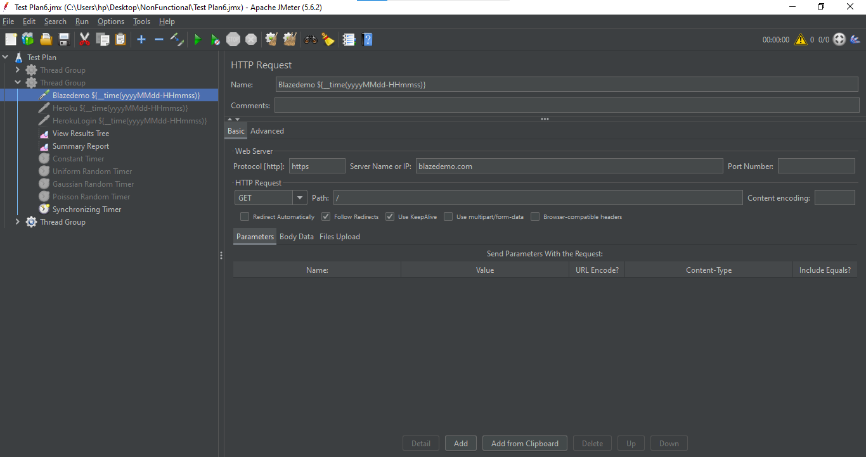

Step4: In 2nd HTTP Request, Give the details as shown below:

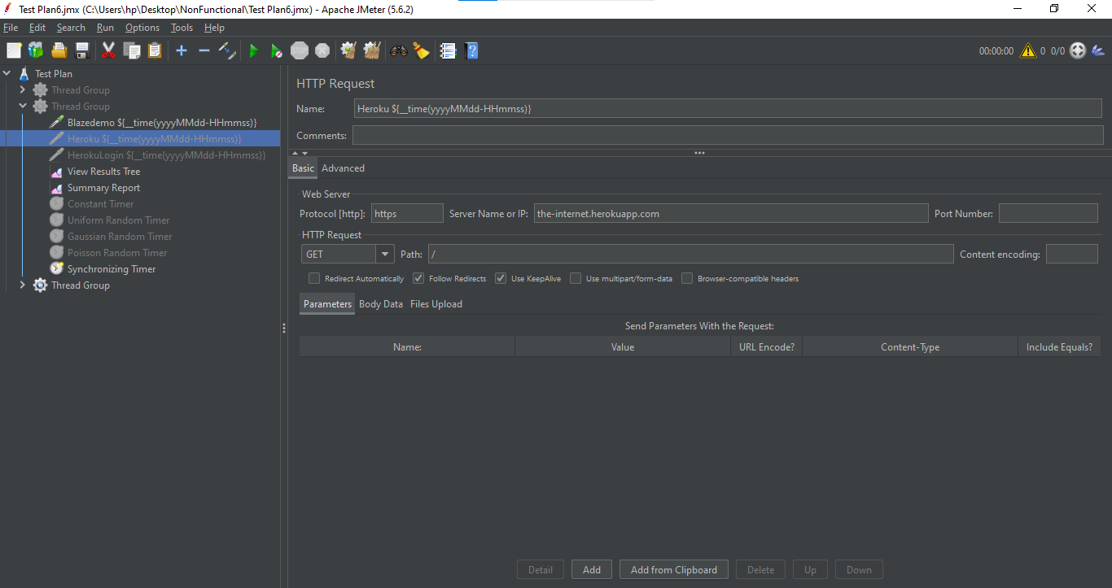

Step5: In 3rd HTTP Request, Give the details as shown below:

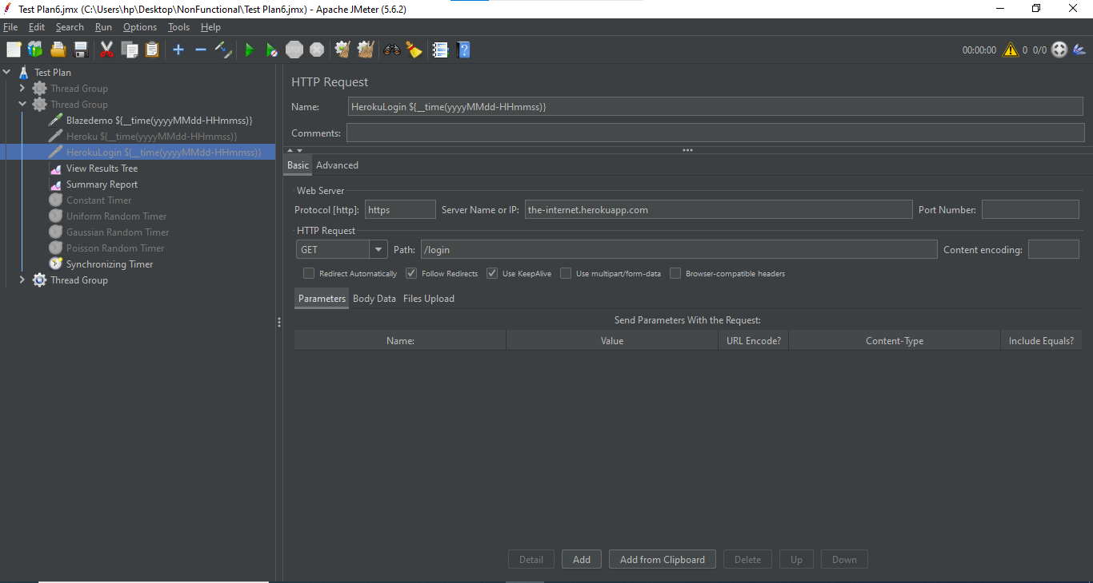

Step6: Right click on Thread Group -> Add -> Timer -> Constant Timer

Step7: In Constant Timer, Give the Thread delay as 300 milliseconds

Step8: Right click on Thread Group -> Add -> Listener -> View Results tree (to see the output)

Step9: Right click on Thread Group -> Add -> Listener -> Summary Report (to see the report of output)

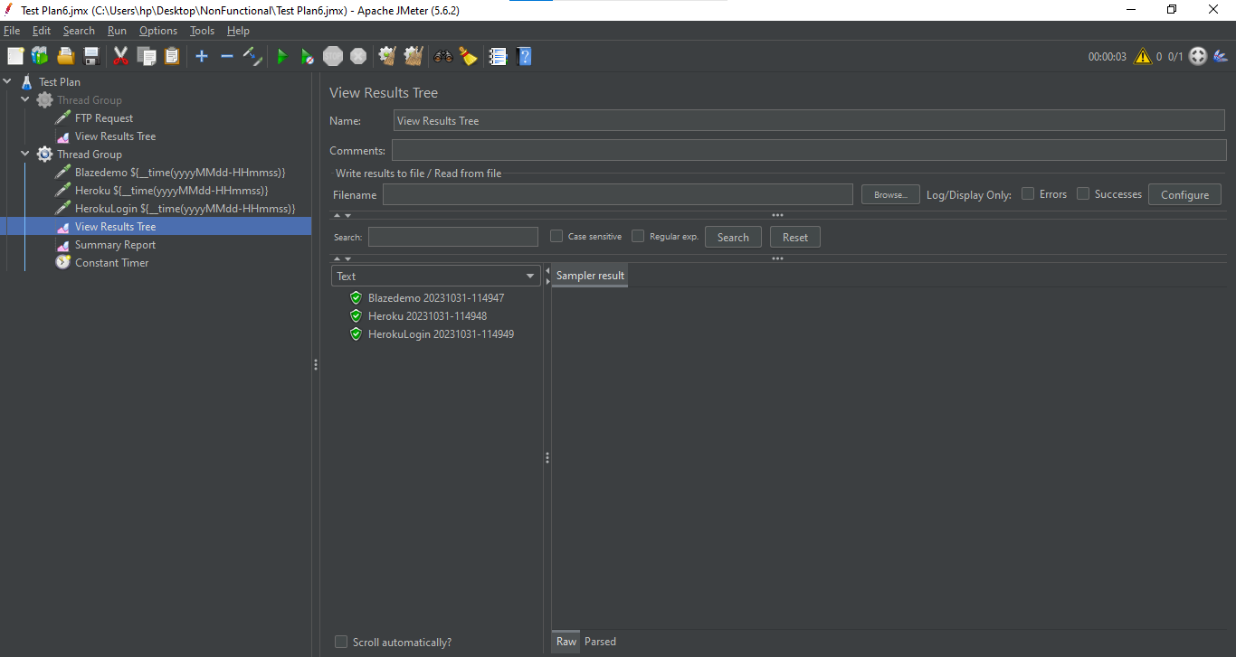

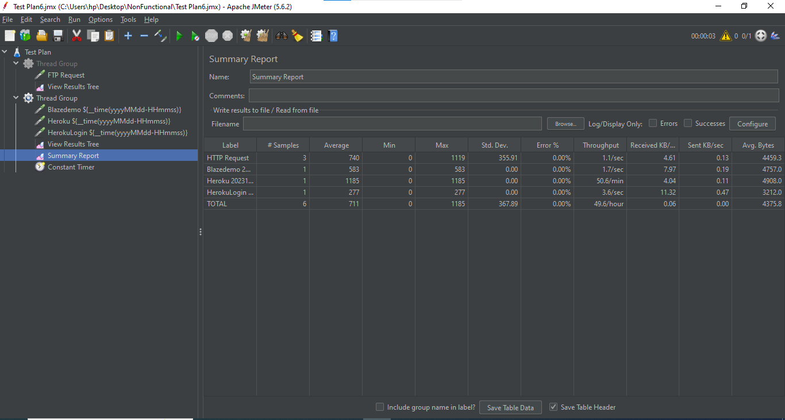

Gaussian Timer:

Step1: Take the same Thread Group as of Constant Timer

Step2: Disable the Constant Timer

Step3: Right click on Thread Group -> Add -> Timer -> Gaussian Random Timer

Step4: In Gaussian Random Timer -> Give the Deviation as (1000 milliseconds) -> Give the Constant Delay Offset as (3000 milliseconds)

Step5: Save it and execute it to see the Output

In View Results Tree:

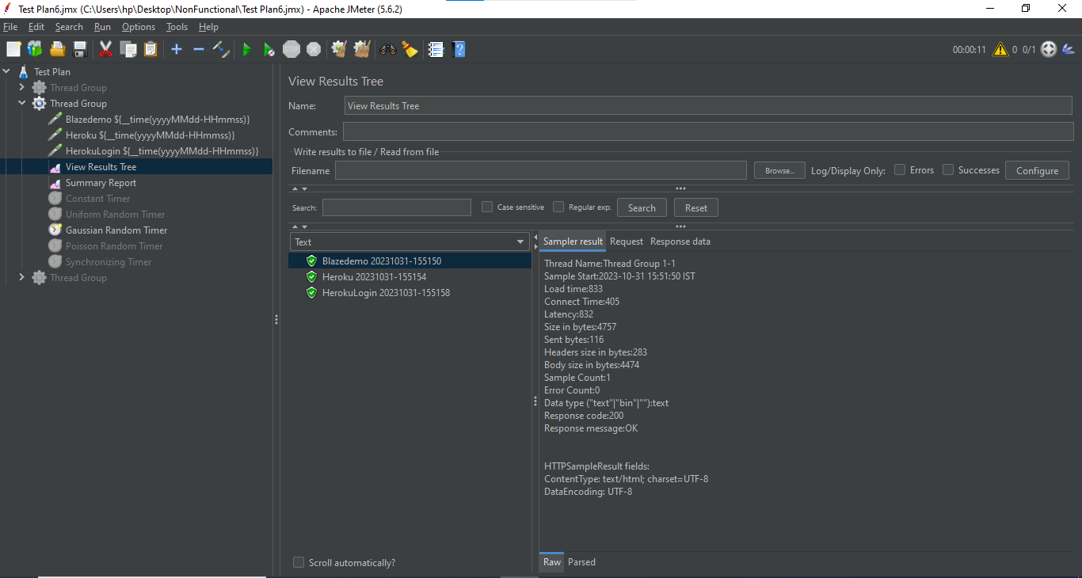

Summary Report:

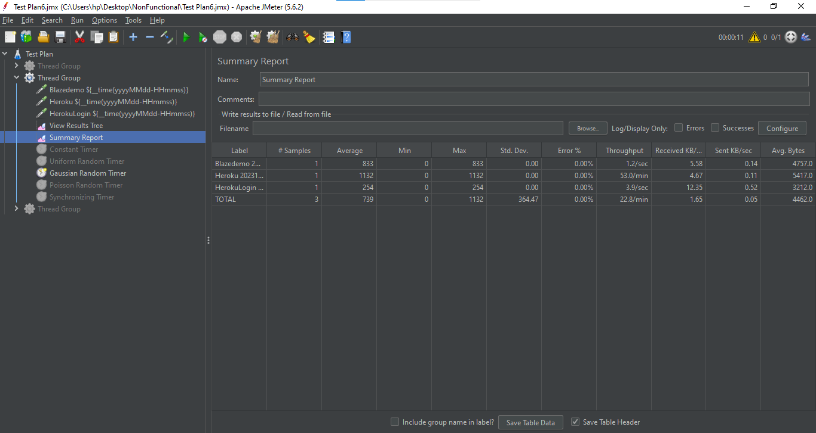

Poisson Timer:

Step1: Take the same Thread Group as of Constant Timer

Step2: Disable the Constant Timer and Gaussian Timer

Step3: Right click on Thread Group -> Add -> Timer -> Poisson Random Timer

Step4: In Poisson Random Timer -> Give the Lambda as (1000 milliseconds) -> Give the Constant Delay Offset as (3000 milliseconds)

Step5: Save it and execute it to see the Output

In View Results Tree:

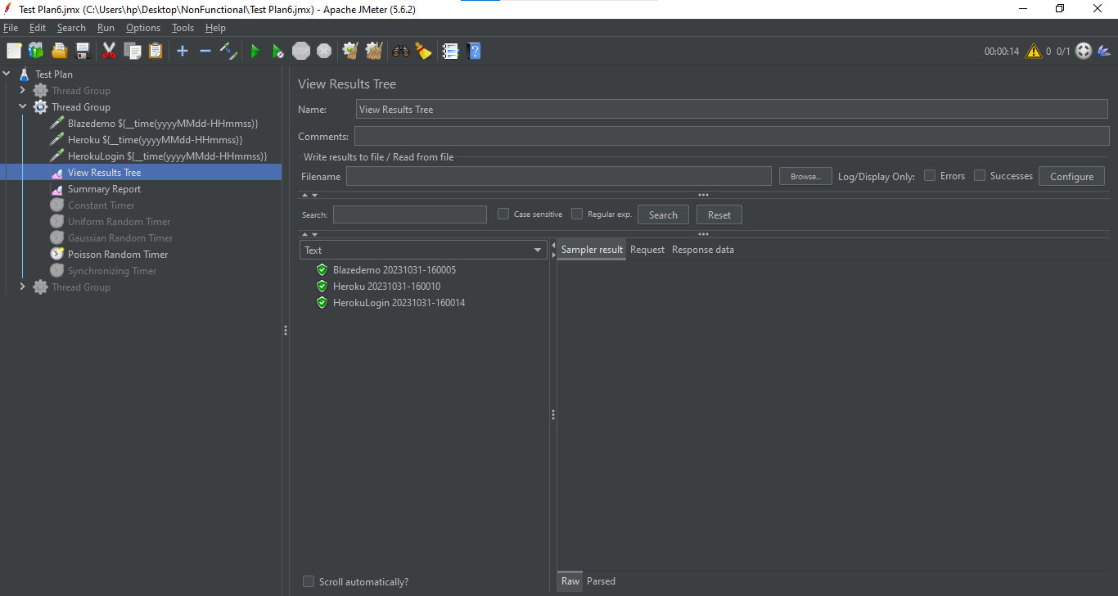

Summary Report:

